Project Documentation

Movie Data Analytics Project Documentation

Project Overview
The goal of this project is to analyse the movie_metadata.csv dataset to uncover the key factors that drive a movie's success. We aim to identify trends in IMDb scores, gross revenue, and budget allocations to help production houses make data-driven decisions on which genres or directors are most likely to yield a high return on investment (ROI).

2. Tools Used
- Microsoft Excel
- Power BI

3. Dataset

Source: movie_metadata.csv

Key Columns: Movie_Title, Director_Name, Genres, Budget, Gross, IMDb_Score, Language, and Country

4. Steps Followed
- Excel Power Query: Steps & Logic
In this stage, I focused on "Data Cleaning" to ensure the analysis wouldn't be skewed by errors.
- Removing Duplicates: Removed duplicate movie entries based on the movie_title to ensure unique records.
- Handling Missing Values: * Filtered out rows where Gross or Budget were null (since ROI cannot be calculated without these).
  - Replaced null values in Director_Name with "Unknown".
- Data Type Conversion: Ensured Budget and Gross were set to Currency and IMDb_Score to Decimal Number.
- Genre Splitting: Since the Genres column contained multiple values (e.g., Action|Adventure|Sci-Fi), I used Split Column by Delimiter ("|") to better categorize the data.
- Power BI: Data Modeling & DAX
After importing the cleaned data into Power BI, I created specific logic to answer our problem statement.
Calculated Columns:
- Profit: Profit = movie_metadata[gross] - movie_metadata[budget]
- ROI %: ROI % = (movie_metadata[Profit] / movie_metadata[budget]) * 100
- Score Category: A "Switch" logic to group movies into High, Medium, and Low based on IMDb scores.
  - Measures (Calculated on the fly):
- Average IMDb Score: Avg Score = AVERAGE(movie_metadata[imdb_score])
- Total Gross Revenue: Total Gross = SUM(movie_metadata[gross])
- Visualization & Logic
I built the dashboard to provide a "Macro to Micro" view of the movie industry:
- KPI Cards: Displaying Total Revenue, Average IMDb Score, and Total Movies analyzed.
- Top 10 Directors by Gross: A Bar Chart to show which directors bring in the most money.
- Budget vs. Revenue Correlation: A Scatter Plot to see if a higher budget actually results in a higher IMDb score.
- Genre Slicer: A tool allowing the user to filter the entire dashboard by genre (e.g., "Show me only Horror movies").

5. Key Insights
- Popularity vs. Profit: High audience engagement (votes/popularity) correlates strongly with profit, whereas a high budget alone does not guarantee financial success.
- Genre Dominance: Action, Adventure, and Comedy are the most frequent genres, but smaller genres like Animation often show a higher average ROI %.
- Language Bias: Over 90% of the top-grossing films are in the English language and produced in the USA, suggesting a strong geographic concentration of financial success.
- Director Impact: A "Top 10 Directors" bar chart reveals that a small group of directors consistently maintains high IMDb scores regardless of budget size.

6. Screenshots
Pre-processed File :
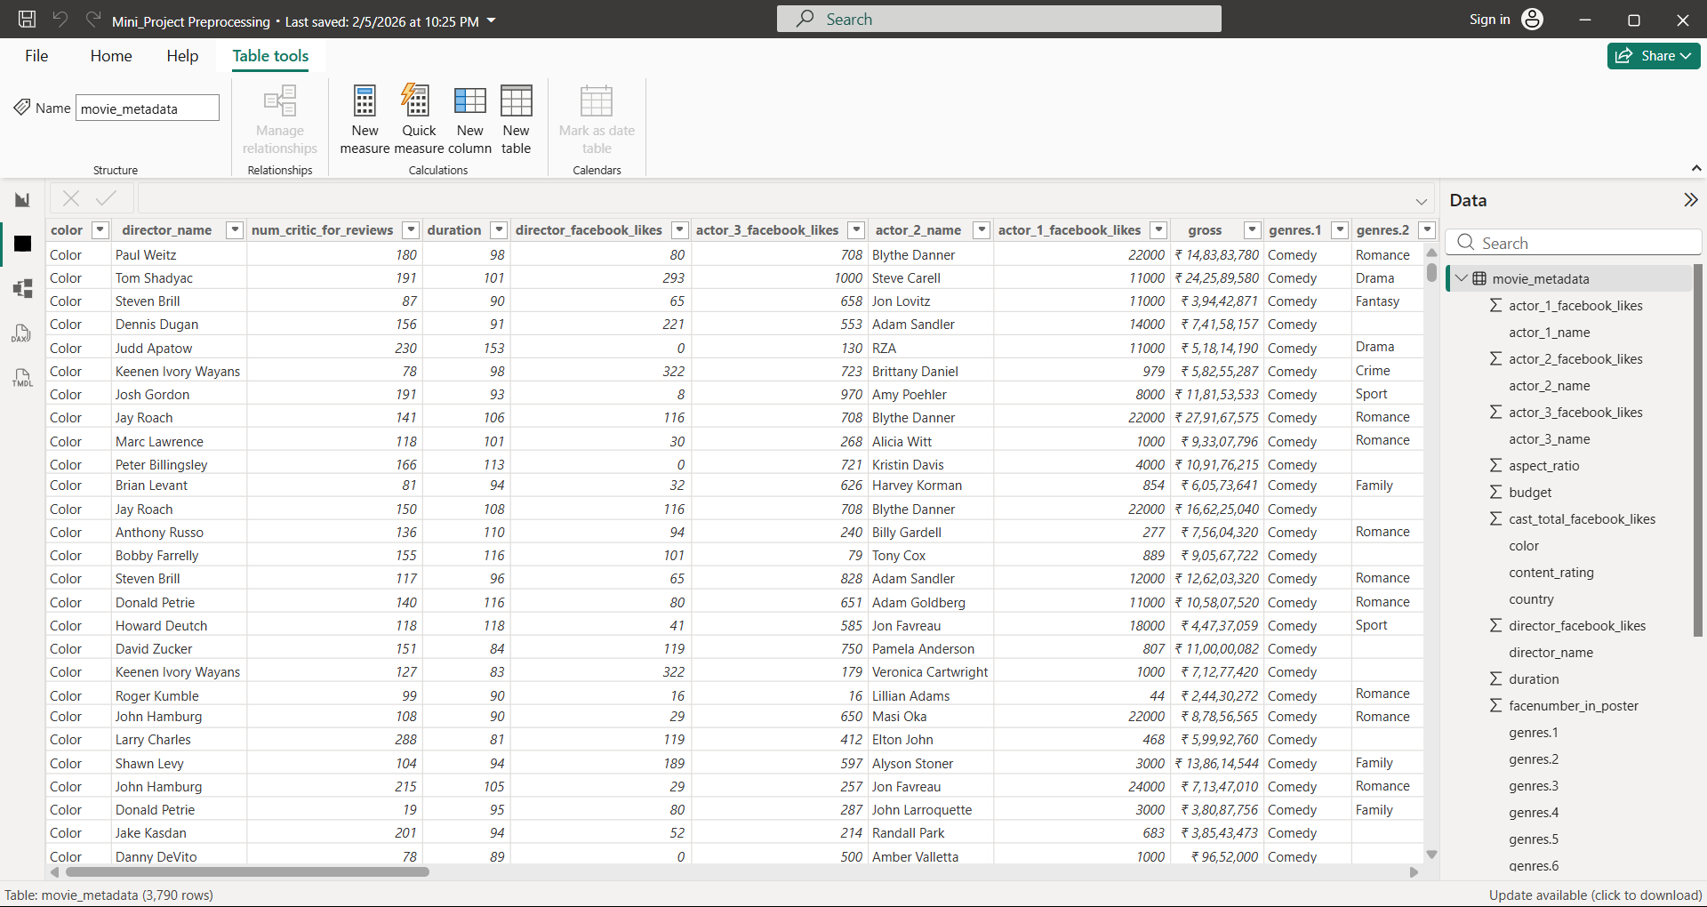

Visualization File :
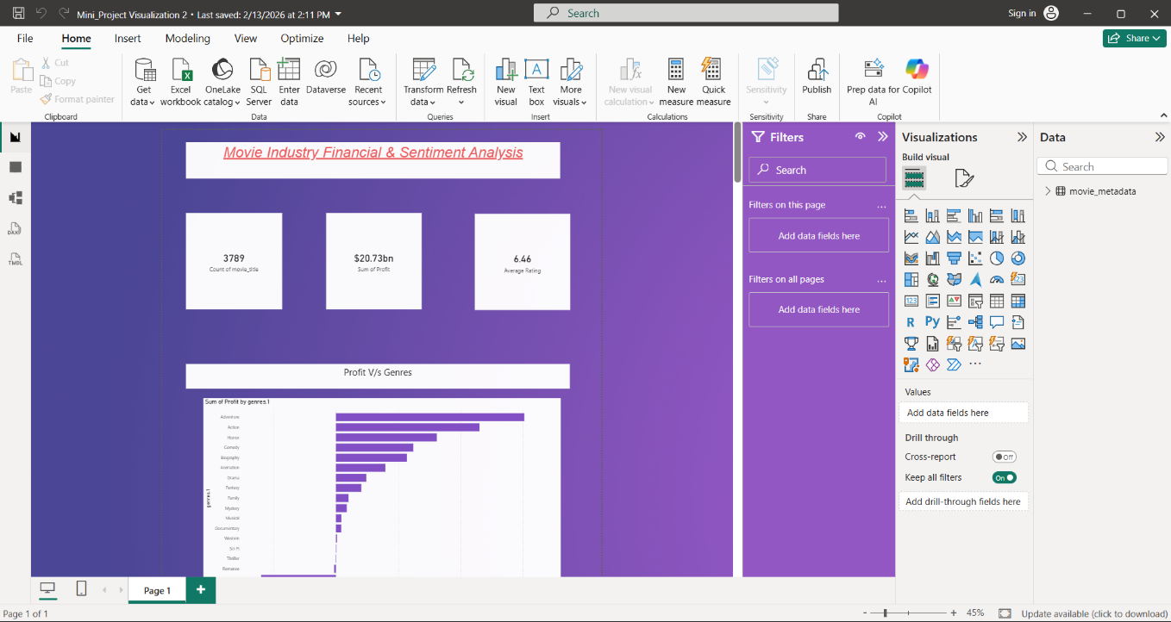

7. Files Included
- Mini_Project Preprocessing.pbix – The cleaned data and Power Query logic.
- Mini_Project Visualization.pbix – The interactive Power BI dashboard.
- README.md – Project overview and instructions.

8. How to Use
- Open Mini_Project Preprocessing.pbix to view the cleaned data.
- Open Mini_Project Visualization.pbix in Power BI Desktop to explore the visuals.

